Digital Literacy

Submitted by: AARYESH RAHUL THORAT
Registration Number: 25MIP10076

Project Task

Task- 1- Presentation

Task 1 Presentation
Create a one-page infographic using tools like Canva.
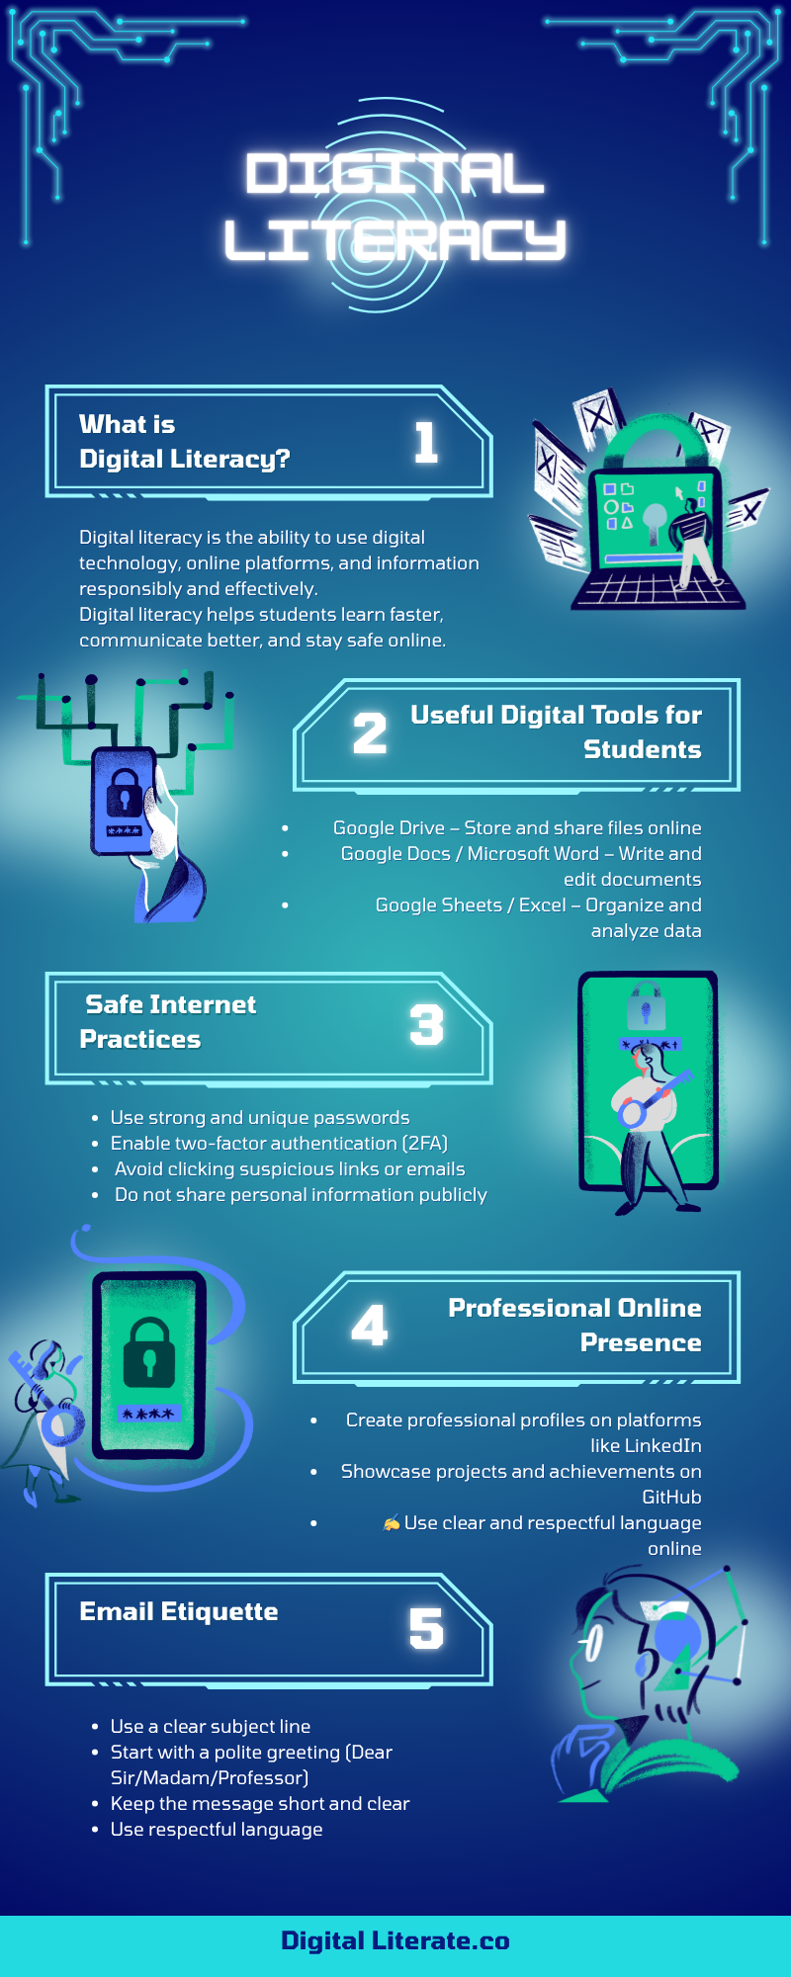

Reflection Report on Canva
For this task, I used Canva, a free online design tool, to create my Digital Literacy infographic. Canva was very helpful because it offers a variety of ready-made templates, icons, and design elements that make it easy to design visually appealing content, even for beginners. I chose a simple infographic template and arranged the information into five sections: what digital literacy is, useful digital tools, safe internet practices, maintaining a professional online presence, and email etiquette. To make the information easy to read and understand, I used icons and short bullet points.
While using Canva, I realized how effective visual design can be in making information easier to remember. Using colours, icons, and a clear layout made the infographic more engaging compared to plain text. The most challenging part was selecting the right layout and making sure all the information fit neatly on one page without making it look crowded. Overall, Canva made the design process straightforward and helped me present the topic in a clear and attractive way.

